Karen Soui Lee

COMP_SCI 130-0

Composition Analysis

[Website: Partake Foods]

Website link for Partake Foods: <https://partakefoods.com/>

The website that I analyzed was Partake Foods that sells gluten-free, vegan, non-GMO baked goods. The values and priorities that the website communicates is inclusion of the individuals who cannot access baked goods due to dietary restrictions. With the brand identity being diversity and inclusion, the website simple and intuitive to navigate for any user with a definitive visual hierarchy. The assortment of colors used throughout the website has strong color contrast and the interactive elements are noticeable for any individual with varying visual capacity.

[Design Analysis]

The design helps to communicate these priorities through a wide range of colors along with clear distinctions in spacing to increase usability. In Figure 1, the promotions Partake Foods offers demonstrates alignment by having the text in the left right corner and the images in the bottom right corner. In Figure 2, the principle of proximity is shown through the navigation bar as the product description section and the social media section is separated. In Figure 3, repetition is clearly shown through similar symbols in allergens that the product is free from.

The strengths of the design of this website is that Partake Foods uses good color contrast and legible font style and size. The limitation of the design of this website is that the products that are displayed are extremely large in size that it can be overbearing for users without disabilities or impairments.

[Comparison]

Website link for Hippeas: <https://hippeas.com/>

Website link for UNREAL: <https://unrealsnacks.com/>

Website link for Feastables: <https://feastables.com/>

Comparable websites would be E-commerce sites that sell snack and food items for healthy diets like Hippeas, UNREAL, Feastables. The following websites utilize vibrant colors as well as sizable fonts to create visual interest. However, out of all the websites, Partake Foods has the best standards that abide by the principles of composition. In Figure 4, the top navigation bar for Hippeas has proximity that is too close which makes the bar harder to visually scan for the users. In Figure 5, the color contrast of the light pink with the red in the UNREAL website is not drastic enough for well-defined visibility. In Figure 6, the system is complex with a lot of visual stimuli.

Accessibility Analysis

[Accessibility check]

1. Keyboard interaction
2. Voiceover
3. Accessibility options

[How did I conduct the accessibility check?]

I conducted these accessibility checks through taking a few tests from Rob Dodson’s video and the article by Karl Groves. I started off with the keyboard interaction check where I didn’t use a mouse or the trackpad to navigate any of the options on the website, seen in Figure 7. I was able to reach all the links that were interactive. For the text-to-speech, I enabled VoiceOver on Mac’s Accessibility features and navigated the website with the tab key (Figure 8). The descriptions provided a general information to guide individuals with visual impairments.

[How accessible was the site?]

The site in fact was very accessible and provided accessibility options directly on the website. As shown in Figure 9, this included the options of: bigger text, bigger cursor, invert colors, contrast, brightness, grayscale, reading line, readable fonts, tooltips, highlight links, and hide images. These options were useful because it included all the major checklists for accessibility.

[What changes could/should it make to increase accessibility?]

However, one downside was that the website for Partake Foods was yet to include alternative text for images. To improve accessibility, the website could use further provide clear descriptions of sematic HTML to define the different parts of the web page.

[Comparison]

Out of the three alternative websites that I examined, only one provided the same accessibility option that Partake Foods did. This website was Feastables. Feastables used an automated web accessibility solution called accessBe. What Feastables used certainly included a lot more accessibility options including choosing the right accessibility profile, content adjustment such as content scaling, adjusting line height, different alignments, and variations of color and orientation adjustments (Figure 10). However, Feastables could have a more reasonable size and emphasis in the content they put on the website as it can appear too large instead of proportional. It can make accommodations to achieve better balance in what is important for the user to notice.

**Appendix**

[Screenshots]

***Figure 1***

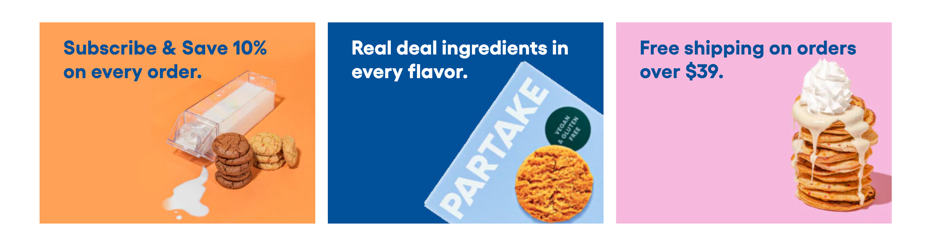

***Figure 2***



***Figure 3***

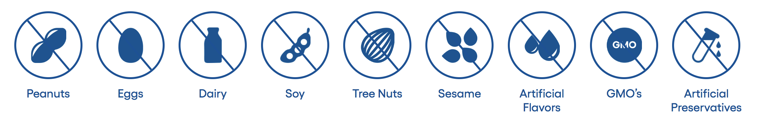

***Figure 4***



***Figure 5*** 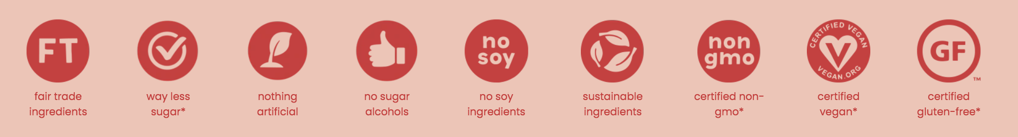

***Figure 6***



***Figure 7***



***Figure 8***

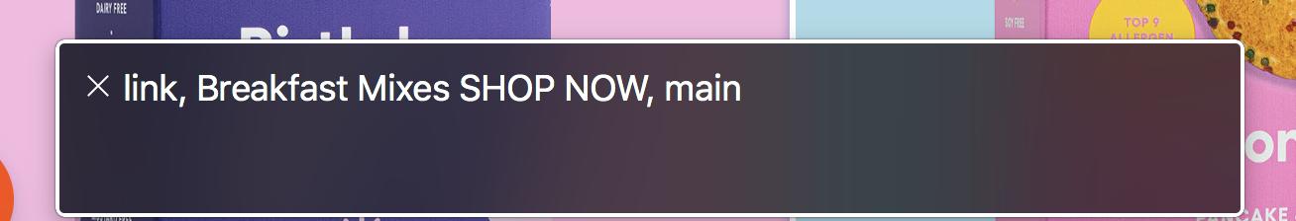

***Figure 9***

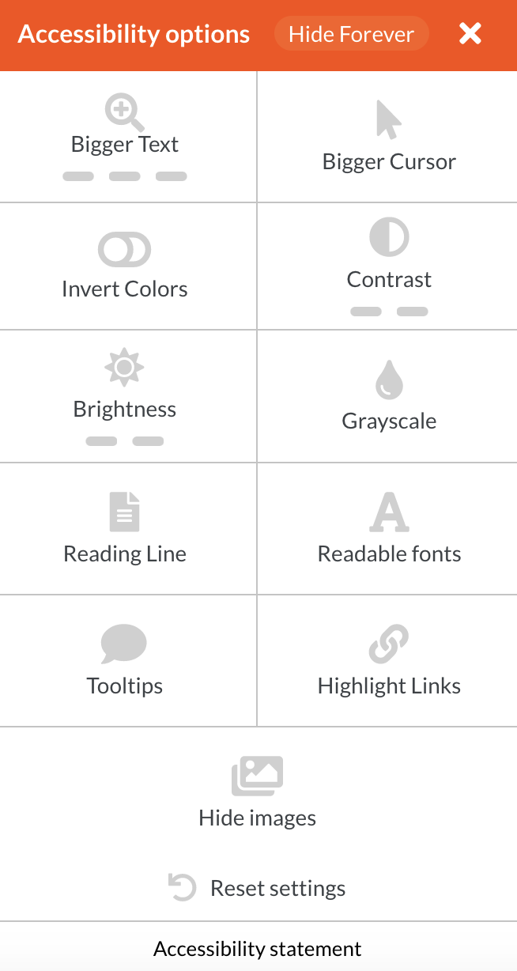

***Figure 10***

